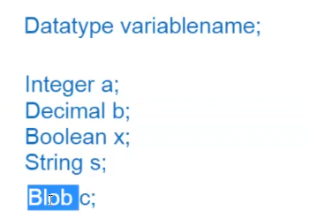

Blob – to store image or file

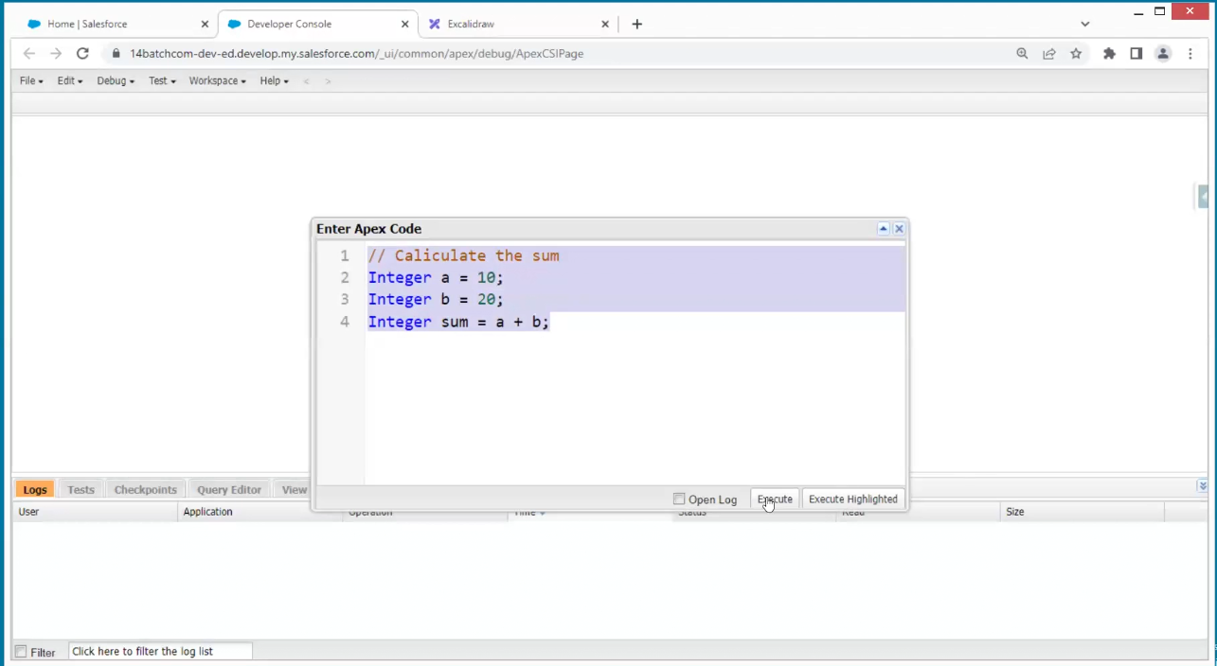

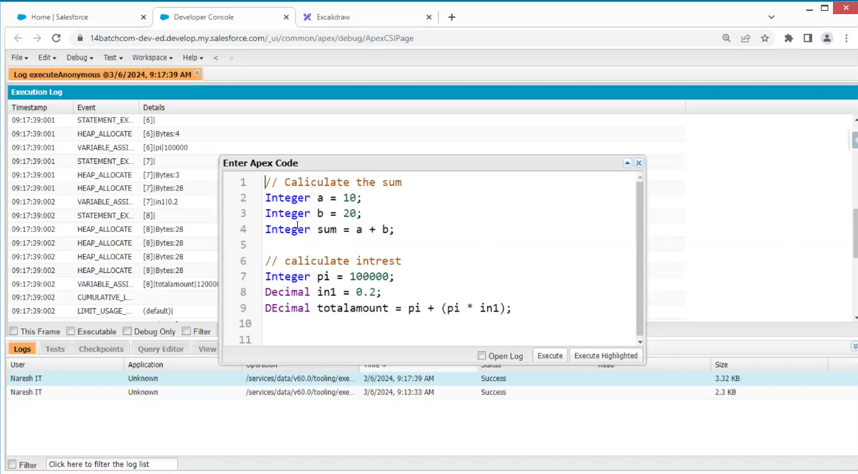

Class and structure is same

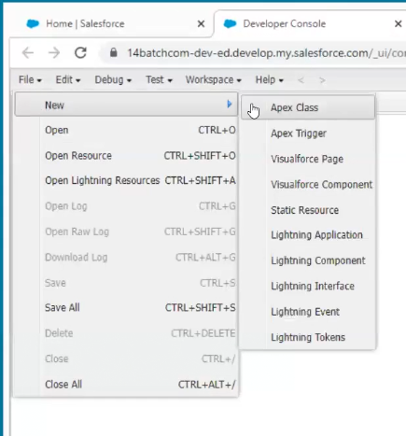

The other way to create a class

Goto setup

In above c is controller

caliculator.apexc

if we write action in java -method

if we write action in c-function

Dynamic memory